**21. More about release records**

--- I have introduced you to the concept of release records where Helm uses the kubernetes secrets to store the release information. In this lecture, we will dive a little deeper into that.

--- To do that, create an installation or execute installation using helm install

**# Install mysql using helm**

--- helm install mysql bitnami/mysql --values /root/mysql/values.yml

**# List the secrets**

--- kubectl get secrets

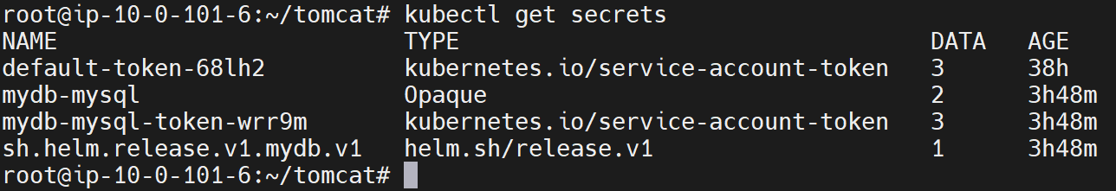

--- **note** – here you can find the secrets for mysql db but also you can see the secrets of helm as well.

--- **sh.helm.release.v1.mydb.v1** - This secret internally will have all the template information and the meta data about the installation. So at any point, if you want to do the same installation again on the Kubernetes cluster, this information is good enough. It has all the Kubernetes templates that are generated as a result of the helm install command.

--- **note** – if you do upgrade then it will create another helm secret.

**# Describe secret.**

--- kubectl get secret sh.helm.release.v1.mydb.v1 -o yaml

--- **important** – when you say helm list, helm fetch. All the information is coming from this secret.

--- **important** – we can create a kubernetes cluster using this secrets.